**Name(s) _______Dannah Gersh______________________**

**________________________________________**

**ECE/CoE 1188: Cyber-Physical Systems Laboratory**

***Lab #3 Worksheet (60 points)***

Fill out all requested items, export to a PDF document and then ***upload this document*** to courseweb. ***Upload separate source code files*** for each part

# **Part A – I/O Interface**

1. 5 pts **Detailed Schematic of Prototype System, including MSP432 Ports and details of I/O Interface**

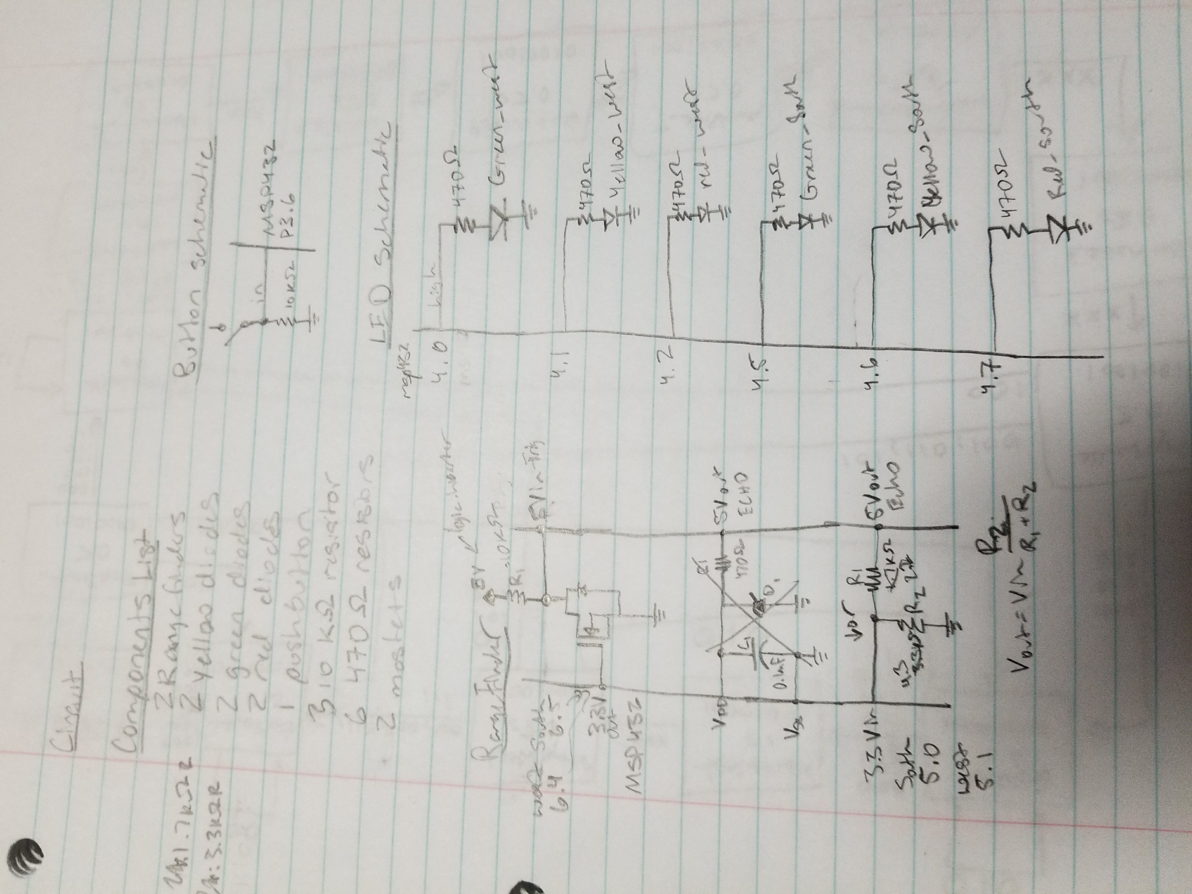

1. 5 pts **Test program used to test pushbutton functionality (upload and name the source Button_test.c)**
2. 5 pts **Test program used to verify LED functionality (upload and name the source LED_test.c)**
3. 5 pts **Photo verifying approach to MSP432 to HC-SR04 input (stepping voltage up)**

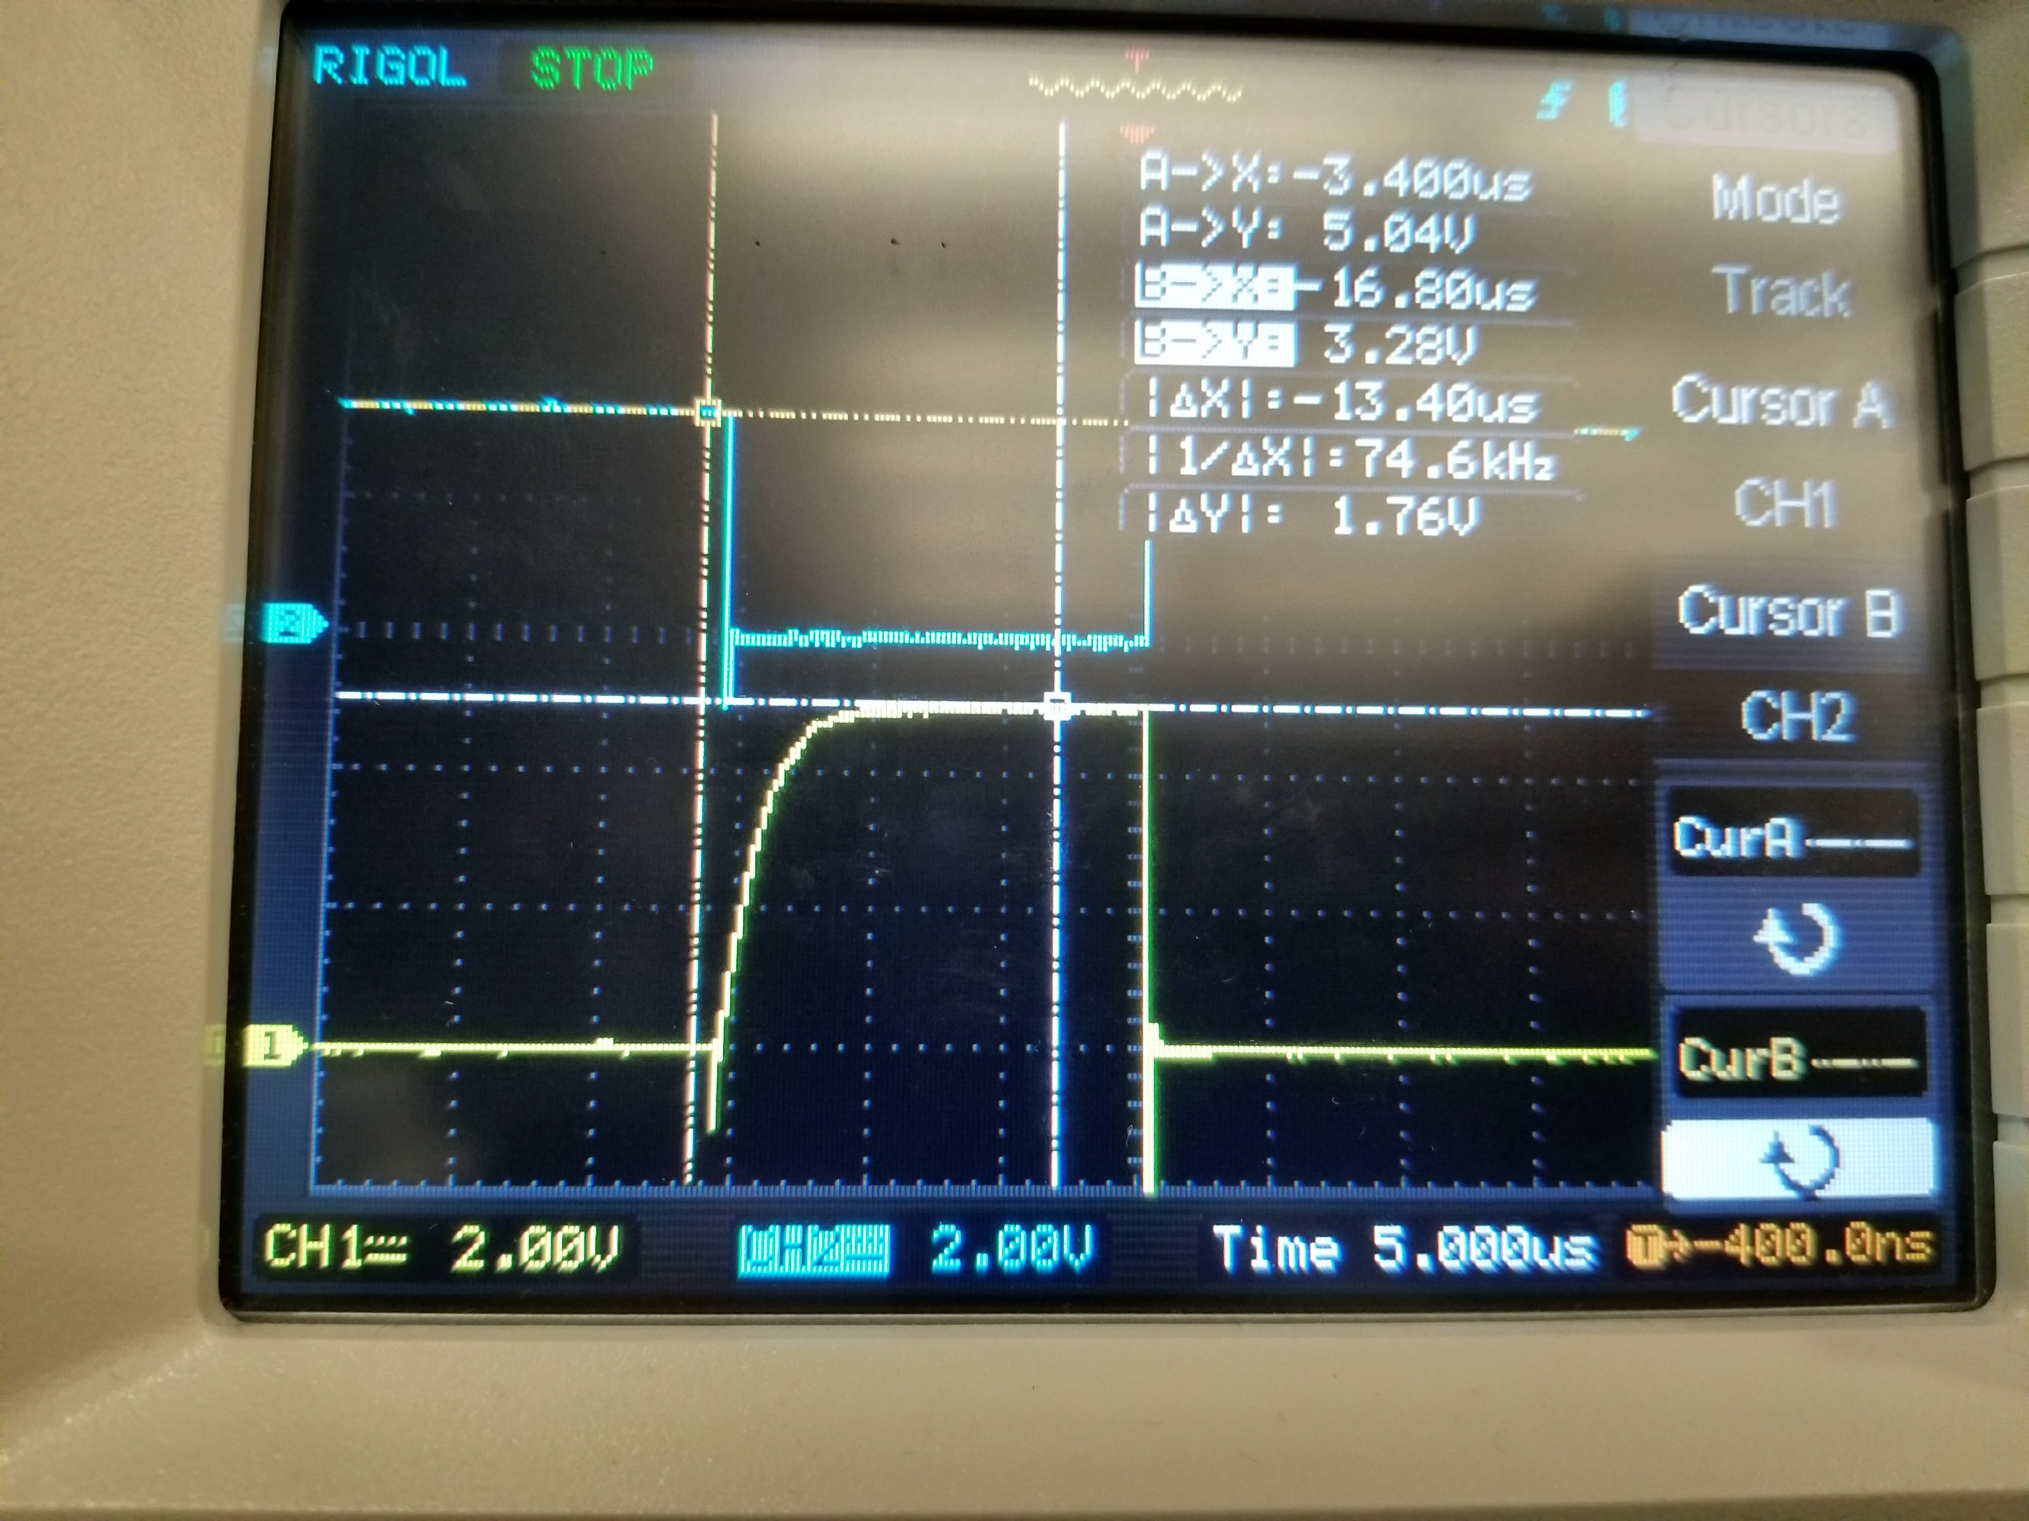

1. 5 pts **Photo verifying HC-SR04 output to MSP432 input interface (stepping voltage down_**

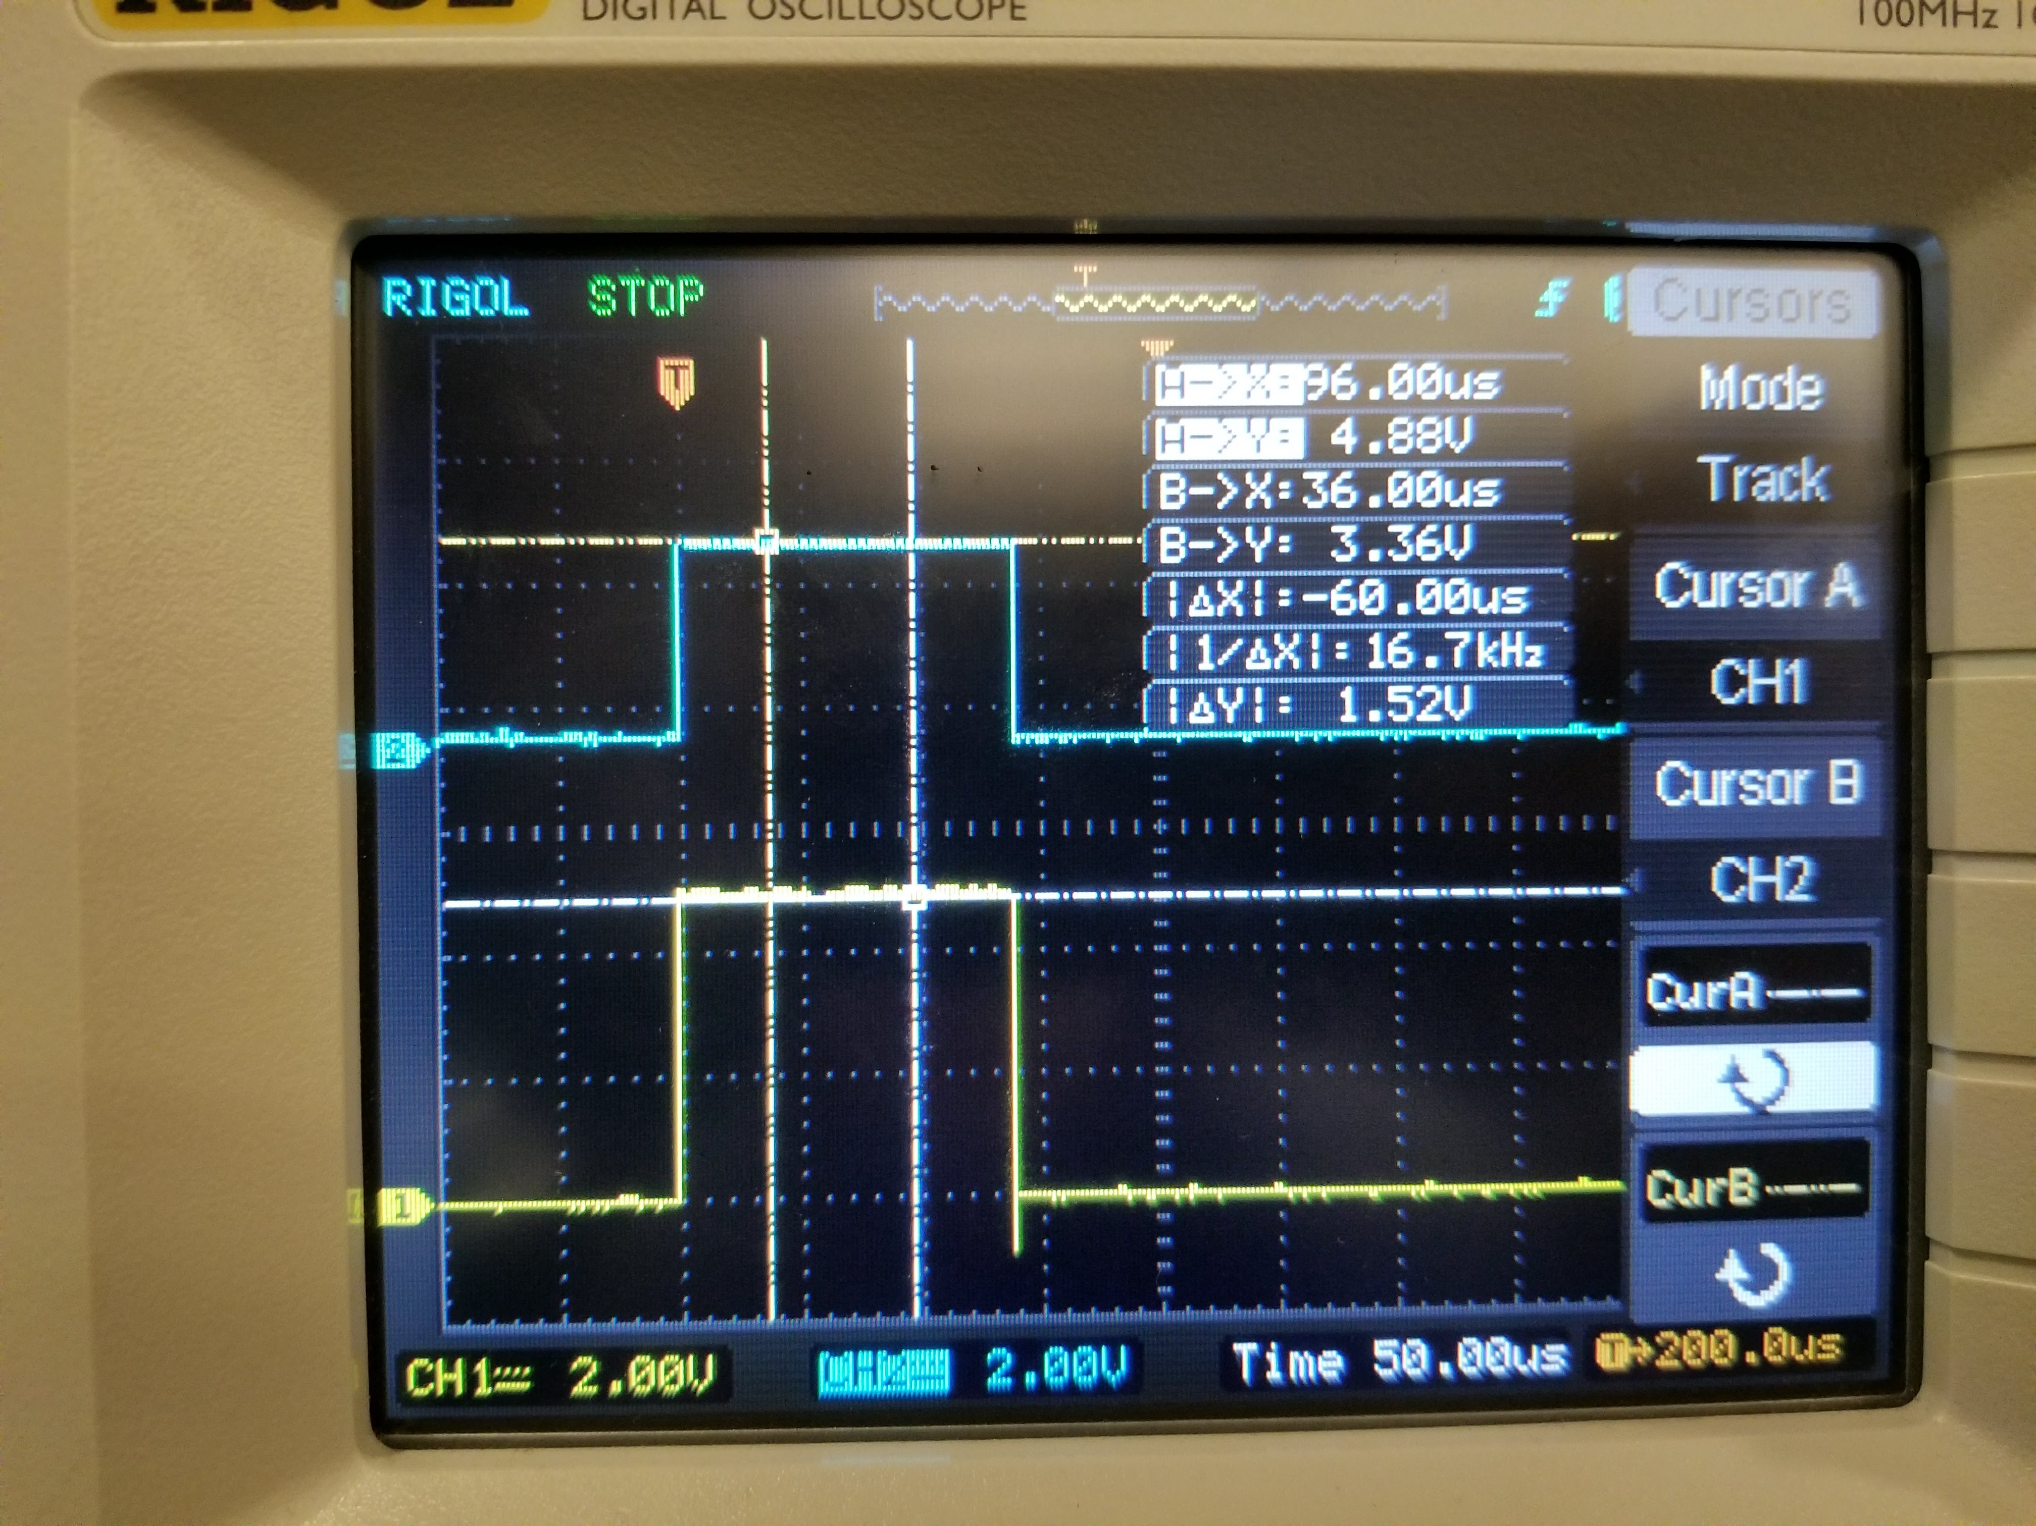

1. 5 pts **Test program used to verify HC-SR04 functionality (upload and name the source range_test.c)**
2. 5 pts **HC-SR04 Calibration Hand Measurements**

|  |  |
| --- | --- |
| Distance Measured | Distance Calculated |
| 2.5 in | 2.52 in |
| 5 in | 5.05 in |
| 2 in | 2.01 in |

# **Part B – FSM Design**

1. 10 pts **FSM Diagram**

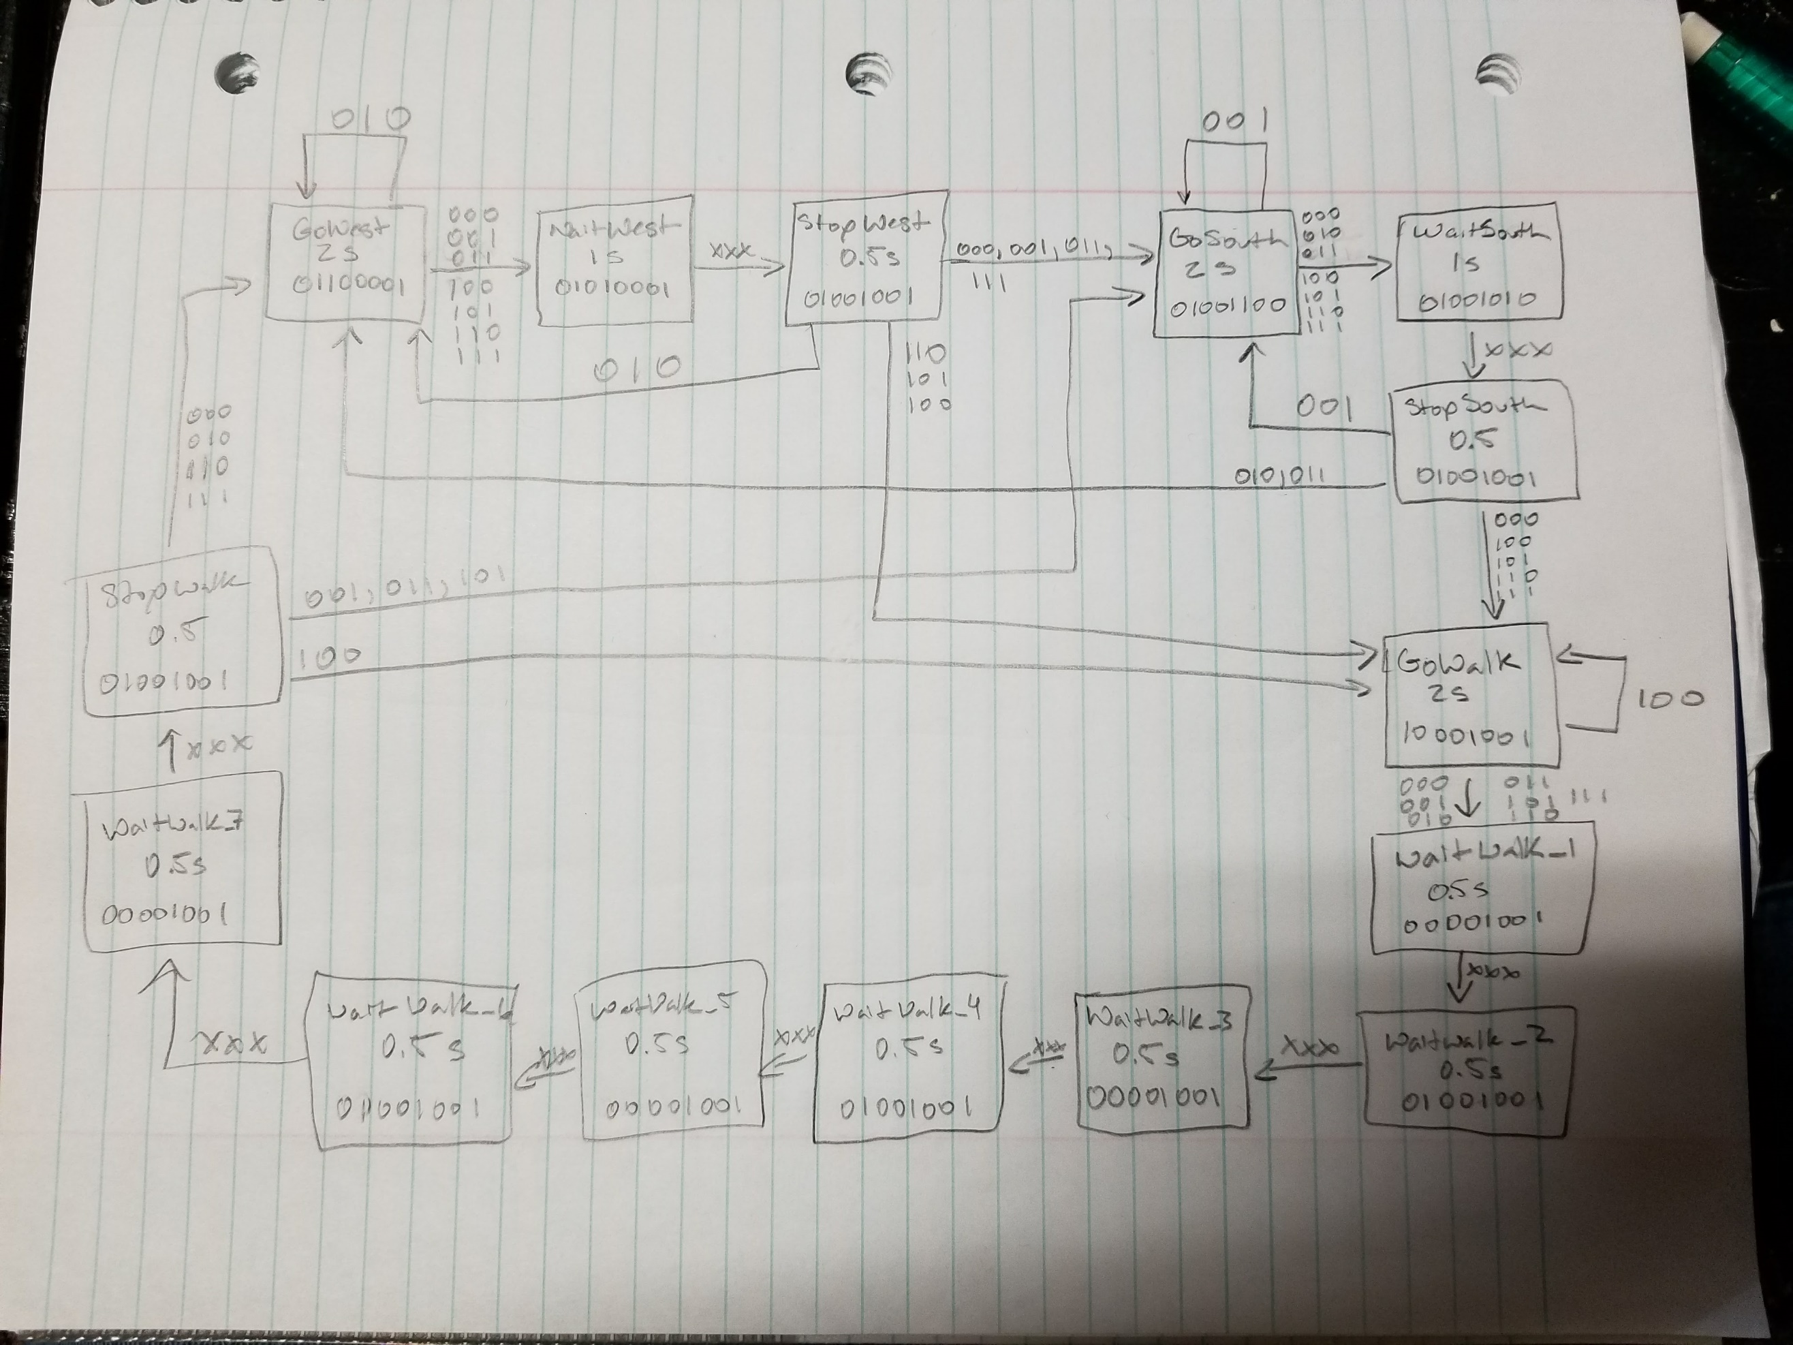

# **Part C – FSM Implementation and TEsting**

1. 10 pts **Main program used to implement traffic controller (name the main source traffic_control.c, be sure to include any additional source/header files needed for your design)**
2. 5 pts **Functional Debugging Results. Select Two traffic scenarios, capture debugging traces showing the traversal through states as indicated by your FSM outputs (displayed in HEX). Label the state associated with each output (e.g Go North, Go East, Etc). Data should be collected with an approximately uniform interval sampling time**

Input buffer fields: bit 2: walk button, bit 1: west RF, bit 0: south RF

Output buffer fields: (bits 7->0) WalkG, WalkR, WestG, WestY, WestR, SouthG, SouthY, SouthR

Scenario 1: no input, cycle through all states, west->south->walk->west….

|  |  |  |  |  |
| --- | --- | --- | --- | --- |
|  | input_buffer | output_buffer | state_buffer | Actual State |
| [0] | 00000000b (Binary) | 01100001b (Binary) | 0x00000DBC (Hex) | GoWest |
| [1] | 00000000b (Binary) | 01010001b (Binary) | 0x00000DE4 (Hex) | WaitWest |
| [2] | 00000000b (Binary) | 01001001b (Binary) | 0x00000E0C (Hex) | StopWest |
| [3] | 00000000b (Binary) | 01001100b (Binary) | 0x00000E34 (Hex) | GoSouth |
| [4] | 00000000b (Binary) | 01001010b (Binary) | 0x00000E5C (Hex) | WaitSouth |
| [5] | 00000000b (Binary) | 01001001b (Binary) | 0x00000E84 (Hex) | StopSouth |
| [6] | 00000000b (Binary) | 10001001b (Binary) | 0x00000EAC (Hex) | GoWalk |
| [7] | 00000000b (Binary) | 00001001b (Binary) | 0x00000ED4 (Hex) | WaitWalk_1 |
| [8] | 00000000b (Binary) | 01001001b (Binary) | 0x00000EFC (Hex) | WaitWalk_2 |
| [9] | 00000000b (Binary) | 00001001b (Binary) | 0x00000F24 (Hex) | WaitWalk_3 |
| [10] | 00000000b (Binary) | 01001001b (Binary) | 0x00000F4C (Hex) | WaitWalk_4 |
| [11] | 00000000b (Binary) | 00001001b (Binary) | 0x00000F74 (Hex) | WaitWalk_5 |
| [12] | 00000000b (Binary) | 01001001b (Binary) | 0x00000F9C (Hex) | WaitWalk_6 |
| [13] | 00000000b (Binary) | 00001001b (Binary) | 0x00000FC4 (Hex) | WaitWalk_7 |
| [14] | 00000000b (Binary) | 01001001b (Binary) | 0x00000FEC (Hex) | StopWalk |
| [15] | 00000000b (Binary) | 01100001b (Binary) | 0x00000DBC (Hex) | GoWest |
| [16] | 00000000b (Binary) | 01010001b (Binary) | 0x00000DE4 (Hex) | WaitWest |
| [17] | 00000000b (Binary) | 01001001b (Binary) | 0x00000E0C (Hex) | StopWest |
| [18] | 00000000b (Binary) | 01001100b (Binary) | 0x00000E34 (Hex) | GoSouth |
| [19] | 00000000b (Binary) | 01001010b (Binary) | 0x00000E5C (Hex) | WaitSouth |
| [20] | 00000000b (Binary) | 01001001b (Binary) | 0x00000E84 (Hex) | StopSouth |
| [21] | 00000000b (Binary) | 10001001b (Binary) | 0x00000EAC (Hex) | GoWalk |
| [22] | 00000000b (Binary) | 00001001b (Binary) | 0x00000ED4 (Hex) | WaitWalk_1 |
| [23] | 00000000b (Binary) | 01001001b (Binary) | 0x00000EFC (Hex) | WaitWalk_2 |

Scenario 2: west sensor active and walk button pressed twice

|  |  |  |  |  |
| --- | --- | --- | --- | --- |
|  | input_buffer | output_buffer | state_buffer | Actual State |
| [0] | 00000000b (Binary) | 01100001b (Binary) | 0x00000DBC (Hex) | GoWest |
| [1] | 00000110b (Binary) | 01010001b (Binary) | 0x00000DE4 (Hex) | WaitWest |
| [2] | 00000110b (Binary) | 01001001b (Binary) | 0x00000E0C (Hex) | StopWest |
| [3] | 00000110b (Binary) | 10001001b (Binary) | 0x00000EAC (Hex) | GoWalk |
| [4] | 00000010b (Binary) | 00001001b (Binary) | 0x00000ED4 (Hex) | WaitWalk_1 |
| [5] | 00000010b (Binary) | 01001001b (Binary) | 0x00000EFC (Hex) | WaitWalk_2 |
| [6] | 00000010b (Binary) | 00001001b (Binary) | 0x00000F24 (Hex) | WaitWalk_3 |
| [7] | 00000010b (Binary) | 01001001b (Binary) | 0x00000F4C (Hex) | WaitWalk_4 |
| [8] | 00000010b (Binary) | 00001001b (Binary) | 0x00000F74 (Hex) | WaitWalk_5 |
| [9] | 00000010b (Binary) | 01001001b (Binary) | 0x00000F9C (Hex) | WaitWalk_6 |
| [10] | 00000010b (Binary) | 00001001b (Binary) | 0x00000FC4 (Hex) | WaitWalk_7 |
| [11] | 00000010b (Binary) | 01001001b (Binary) | 0x00000FEC (Hex) | StopWalk |
| [12] | 00000010b (Binary) | 01100001b (Binary) | 0x00000DBC (Hex) | GoWest |
| [13] | 00000010b (Binary) | 01100001b (Binary) | 0x00000DBC (Hex) | GoWest |
| [14] | 00000010b (Binary) | 01100001b (Binary) | 0x00000DBC (Hex) | GoWest |
| [15] | 00000010b (Binary) | 01100001b (Binary) | 0x00000DBC (Hex) | GoWest |
| [16] | 00000110b (Binary) | 01010001b (Binary) | 0x00000DE4 (Hex) | WaitWest |
| [17] | 00000110b (Binary) | 01001001b (Binary) | 0x00000E0C (Hex) | StopWest |
| [18] | 00000110b (Binary) | 10001001b (Binary) | 0x00000EAC (Hex) | GoWalk |
| [19] | 00000010b (Binary) | 00001001b (Binary) | 0x00000ED4 (Hex) | WaitWalk_1 |
| [20] | 00000010b (Binary) | 01001001b (Binary) | 0x00000EFC (Hex) | WaitWalk_2 |
| [21] | 00000010b (Binary) | 00001001b (Binary) | 0x00000F24 (Hex) | WaitWalk_3 |
| [22] | 00000010b (Binary) | 01001001b (Binary) | 0x00000F4C (Hex) | WaitWalk_4 |
| [23] | 00000010b (Binary) | 00001001b (Binary) | 0x00000F74 (Hex) | WaitWalk_5 |